Rust Fitness Challenge

Visitors complete a quick physical challenge at our booth: push-ups, dips or a timed bar hold.
They earn a place on the live leaderboard, which is tracked on a whiteboard.
Daily winners receive JetBrains licenses and a deliberately tiny, branded 1 kg dumbbell.

The activity can later become a recurring challenge at conferences and online.

How it works
- Choose a challenge: push-ups, dips or timed bar hold.
- Complete one supervised attempt.
- A booth team member verifies the result.
- Add your name and score to the corresponding leaderboard.
- Daily winners are announced at the booth and on social media.
Safety:
- Participation is voluntary.
- Equipment is supervised & exercise demonstrations are provided.
- Participants must stop immediately if they feel pain or discomfort.
Prizes:
- JetBrains All Products Pack licenses
- JetBrains merch
- “1 kg Developer Dumbbell”
- Participation sticker

Branding
Name: Rust & Reps
Tagline: Rust is strongly typed, are you?
Banner:
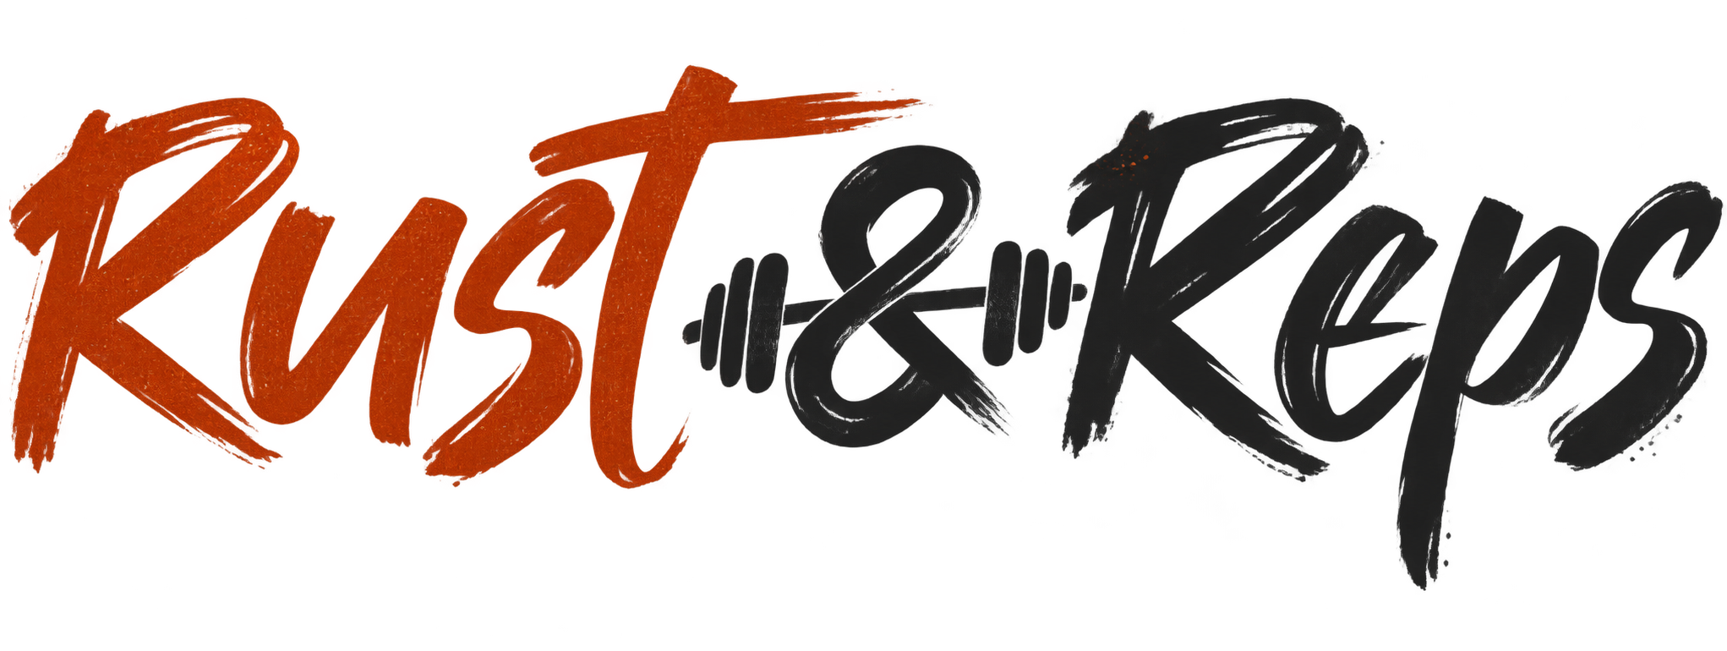
Stickers:
